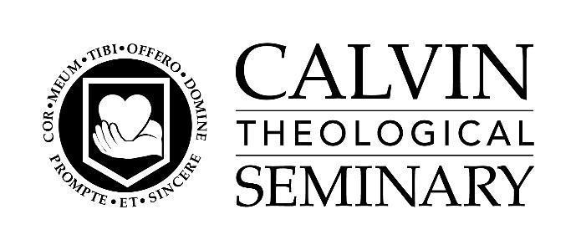

Position Description
Old Testament
CALVIN THEOLOGICAL SEMINARY

Position: Old Testament (open rank)
Reports to: Dean of the Faculty
Status: Full-time, Exempt

The Professor of Old Testament is a regularly-appointed, tenure-track faculty member holding the rank of assistant, associate, or full professor. The position involves the full range of faculty, departmental, and committee privileges and responsibilities at Calvin Theological Seminary. This position emphasizes training students, preparing future scholars, and serving the church in biblical languages and Old Testament theology from a Reformed perspective. The person filling this position will begin his or her responsibilities on July 1, 2026.

To apply, please send a cover letter, unofficial academic transcripts, and curriculum vitae with three recommenders’ names and contact information. Review of application materials will commence on November 1. Please address applications or nominations to Dr. Wilson de Angelo Cunha, The John H. Stek and Martin J. Wyngaarden Professor of Old Testament Studies, and Prof. Jeff Weima, Deppe Family Professor of New Testament at OTSearch@calvinseminary.edu

Personal Qualifications (Character)
The Professor of Old Testament shall:

- Be a godly person, prayerful and persistent in following Jesus Christ, exhibiting the fruit of the Spirit and other Christ-likenesses, including Christian wisdom, honesty, and humility; committed to the Lord and the ministry of the church.
- Be deeply biblical, with knowledge of Scripture written on heart and mind; committed to the Scriptures as God’s infallible word; committed to the Reformed Confessions (the Belgic Confessions, the Heidelberg Catechism, and the Canons of Dort); and willing to sign the Covenant for Officebearers of the CRCNA (Christian Reformed Church in North America).
- Be virtuous in teaching: humble, enthusiastic, honest, curious, compassionate, encouraging, hopeful; generous in offering time and skills to students and colleagues; ready to learn from students as well as teach them; respectful of all students.
- Be virtuous in scholarship: clear, persistent, truthful, curious, and charitable toward those who disagree; teachable; self-aware of strengths and weaknesses; accountable; willing to change and grow as a teacher, mentor, and scholar.
- Be hospitable, making every effort to create a welcoming environment for all.
- Be generous in offering time and skills to students, colleagues, and the general life of the seminary.

Academic and Professional Qualifications

The Old Testament faculty member shall:

- Be truly learned with a broad liberal arts education in humanities and/or sciences as well as a high-quality theological education.
- Be credentialed with a PhD in Old Testament or related area and have a demonstrated teaching, research, and publication record.
- Be thoroughly acquainted with the life of the Christian Church in the world today and broadly familiar with major trends in contemporary theology; able to appreciate and interact with significant biblical, theological, and ministry developments in the majority world.
- Be able to teach clearly, respectfully and creatively, with evident awareness of the presence of God and with apparent attention to the students’ formation for ministry; have sound judgment—balance, fairness, and free of fanaticism.
- Appreciate and interact with significant biblical, theological, and ministry developments in the majority world.
- Ordinarily, be ordained or ordainable in the Christian Reformed Church in North America.

The Calvin Seminary Faculty Handbook’s statement of requirements for all faculty members appears here.

Responsibilities and Tasks

The Professor of Old Testament shall:

- Teach core, elective, and independent study courses in biblical languages and Old Testament theology in the MA, MTS, and MDiv degree programs.
- Teach ThM and PhD courses in various areas of Old Testament theology, early Judaism, and/or ancient Near Eastern languages and literature.
- Supervise ThM and PhD research papers, theses, and other student research.
- Help to form students for ministry, including being available to meet with students serving as an academic advisor, and mentoring warmly and wisely, always ready to listen to students, guide them, pray with them, and model mature pastoral identity for them.
- Engage students, the church, the academy, and the wider culture in the area of biblical and/or ancient Near Eastern languages, early Judaism, and Old Testament theology through writing, preaching, and teaching (including adult education, continuing education seminars, and workshops in the church and community).
- Provide advice to ecclesiastical assemblies and, where appropriate, to congregations and ecclesiastical agencies.
- Extend the seminary curriculum’s reach through available pedagogical technological resources, including online teaching.
- Work with other faculty members cross-departmentally to enhance the integration of the seminary curriculum.
- Help the seminary serve students and congregations of various cultural backgrounds and nationalities in light of the particular challenges they might face.
- Participate in normal faculty responsibilities, including serving on committees and attending faculty meetings, convocation, commencement, chapel services, and seminary community events throughout the year.

Physical Demands/Work Environment

The physical demands of this position do not extend beyond sitting and occasional standing, walking, and reaching. We can make reasonable accommodations to enable individuals with disabilities to perform essential functions. The work in this position occurs within routine office conditions, usually without exposure to hazardous or unpleasant conditions.

Oct 2, 2025

